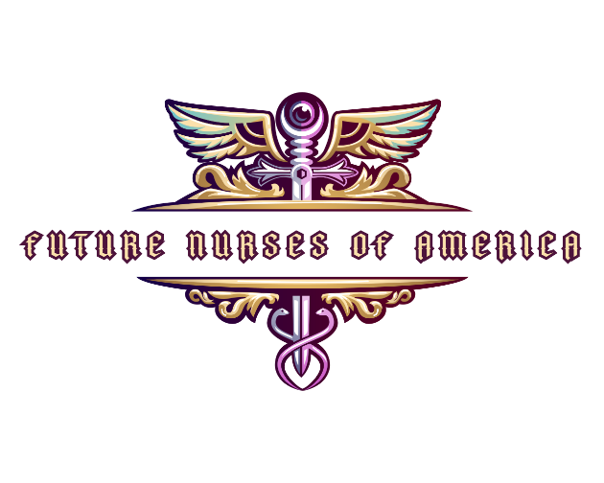

Helping to Make a Difference: Future Nurses of America (FNOA) Scholarship Foundation

**Amount**: **$2000**

Reserved specifically for nursing students who enrolled in an ASN or BSN program, this nursing scholarship is based on merit and need and is given to a student seeking to acquire a degree in nursing.

**Requirements**

* Be enrolled in a nursing program
* Have a minimum GPA of 2.75 (**please send copy of unofficial transcript with application**)
* Submit a **250–500-word essay**, **Tik-Tok**, OR a **1–3-minute video** answering the following the prompt questions below. Only one is required the video or essay.

**Essay Prompt**: Choose one.

* 1. **How will the FNOA scholarship assist you in obtaining a fresh start in life? Also, discuss in your essay about any challenges or obstacles you have dealt with and overcome in life and how this will help you succeed in college and beyond.**
  2. **What most intrigues you about nursing? Also, explain why you would be a good recipient for this scholarship.**

Deadlines

All application materials must be received by deadline listed on the website.

The FNOA team will review all application materials and the recipients of our nursing scholarships will be announced two weeks after deadline.

Selection Process

The FNOA team will choose the top applicants for the nursing scholarship based on the merit of their applications.

* The formal application (35%) will be judged on academic standing, community involvement and financial need.
* Essays, Tik-Toks. or videos (65%) will be judged according to the student’s ability to articulate their goals, motivation and vision for their career and the future of nursing as related to the question.

Application Status

Selected nursing scholarship recipients will be notified either by email or phone; it is critical that this submitted information is correct.

Once contacted, the scholarship recipient will need to provide a photo and go through a brief interview with a FNOA representative:

*\*These nursing scholarships are non-renewable.*

### General Terms & Conditions

* All applicants must be US citizens to be considered for an award.
* Applicant can only apply for scholarship once a year.
* All contact information must be accurate so we may get in touch with you. Nursing scholarship nominations will be notified by email and/or phone. We are not responsible for mistakes or errors in contact details. If you cannot be contacted within 3 days of your nomination, you will be disqualified.
* Any applications found to contain false or misleading misinformation will be immediately disqualified.
* All essays must be the original work of the applicant, any essays found to contain plagiarized material, either full or in-part, will be immediately disqualified.
* Nursing scholarship recipients are performed at the sole discretion of the FNOA Scholarship Foundation.
* Winners must be enrolled at an accredited college or university.
* Finalists will be required to provide proof of enrollment and GPA. Nursing scholarships funds will be paid directly to the school.
* The student must submit a payment form indicating exactly where the funds should be sent. Failure to properly complete this form could result in scholarship disqualification.
* Nursing scholarship recipients will be required to submit a current photo or video and sign a release granting FNOA the right to use this information on their site. By applying for the FNOA’s scholarship, the applicant agrees to allow FNOA.org to use their name, photo/video, an approved biography, and any question responses from their application materials on their website in the event they are selected. Quotes and/or original transcript from scholarship interviews are the property of the FNOA Foundation and we reserve the right to publish portions or full copies of the interview.
* The FNOA Foundation retains the right to change award requirements at any time.
* The FNOA Foundation promises to maintain the privacy of all scholarship applicants; their information will not be sold or distributed.
* Refer to the eligibility requirements for more details.
* In the unlikely event that no applicants meet the set criteria to qualify for an award, FNOA reserves the right to withhold all prize amounts until the next trimester.

*Future Nurses of America does not discriminate based on race, creed, sexual orientation, age or disability status. All applicants will be judged according to the merit of their submitted materials.*